|  |  |
| --- | --- |
| C:\Users\Hare Krishna\Desktop\WhatsApp Image 2022-08-25 at 8.10.42 PM.jpeg  Contact Information:  WZ -196/3B, 3rd Floor  Virender Nagar, Janakpuri  New-Delhi-110058  Mobile No. +91 9582068465  +91 8076646590  +91 9540413119  E-Mail:  [devbratakd94@gmail.com](mailto:devbratakd94@gmail.com)  Subrototkd91@gmail.com  Personal Data  Date of Birth : 17/12/1994.  Gender : Male  Marital Status : Single | (AFFILIATED TO TAEKWON-DO FEDERATION TO DELHI) DE BABRATA SADHUKAN 2ND DAN BLACK BELT(INTERNATIONAL TAEKWONDO FEDERATION)NATIONAL UMPIRE, INSTRUCTOR & NATIONAL PLAYER **SILVER MEDALIST**  Objective  To bring back the joy of learning Taekwondo.  **PROFESSIONAL QUALIFICATIONS**   * + - * 2nd DAN Black Belt from ITF. * And 1st Dan Black Belt From World Taekwon-do Federation * Qualified Nation Umpire from Taekwondo Association of India.   **WORK EXPERIENCE (05 years & above)**   * LANCE Fort International School Burar New Delhi From 2016. * Mother’s Pride Senior Secondary School in Burari New Delhi From 2016 * VSPK International School in Pritampura From 2022. * Worked in Mother’s Pride, Gurugaon 52 For 2 Years * Worked in Mother’s Pride, Model Town for 3 Years. * White Canvas School Noida * Apple Blossom School Palam Vihar * Toddler’s home nursery School No. 8 dhaka Crossing Kingsway Camp Delhi.   **WORKSHOPS/SEMINARS ATTENDED**  I teach taekwondo many of School & Coaching center and Indo My Job honestly and sincerely.   * Provide Part time Coach For Taekwon-do in schools. * Running own Institute in the name of J.M.D Taekwon-do club affiliated to Taekwon-do Federation of Delhi. * I am a Coach of 10th schools and also training 17th coaching center and also 5 coaches work with me." * Following name of Coaching centers:-  1. Paschim Vihar 2. Vikaspuri 3. Dwarka 11,1,7,6 4. Shalimar Bagh 3 places 5. Ashok Vihar 6. Burari 7. Mukharji Nagar 8. Shankar Vihar 9. Gurgaon Sec 48,92 10. Punjabi Bagh 11. Rohini 12. NSG Samalka |

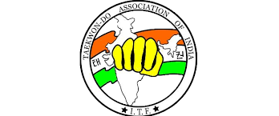**JMD TAEKWON-DO CLUB**

* Our JMD Taekwon-do club achieved in 29 Delhi State Taekwon-do Championship November 2017. Was 3nd Position.
* 31 Delhi State Taekwondo championships November 2019.
* 32 Delhi State Taekwondo Championships 2022.
* JMD Taekwondo Student was also international Participated in Malaysia in year 2019. Silver Medal

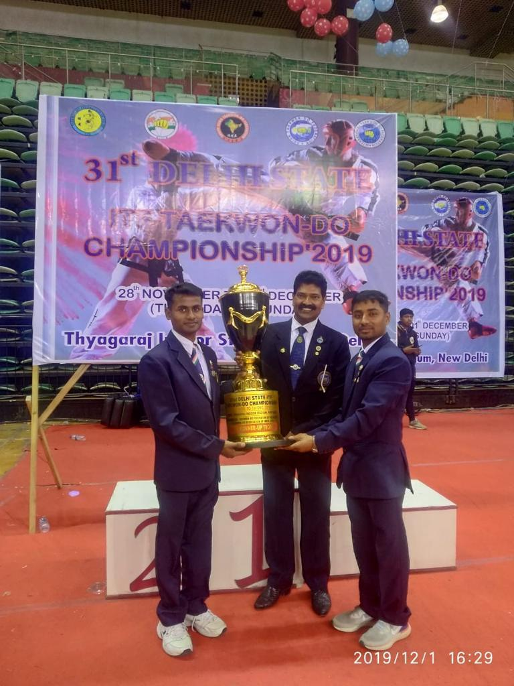

**Our Club has achieved the following medals for following Competitions**

GOLD SILVER BRONZE

State level competition – 30 15 20

Zonal's competition - 10 5 10

National Competition – 10 15 15

International competition – - 1 -

I hope you will consider including Taekwon-do classes for the Students in your Estrrmed school as a Part of their curriculum and await your kind response so that the undersigned could meet you to discuss the matten in detail.

with best regards:

DEBABRATA SADHUKHAN

2nd dan Black belt.

GENERAL SECRETRY

(JAI MATA DI TAEKWON-DO Club Delhi)